***PROJECT REPORT***

***OF***

**SIMPLE TV TO SMART TV**

BACHELOR OF ENGINEERING

**COMPUTER SCIENCE & ENGINEERING**

**6TH SEMESTER**

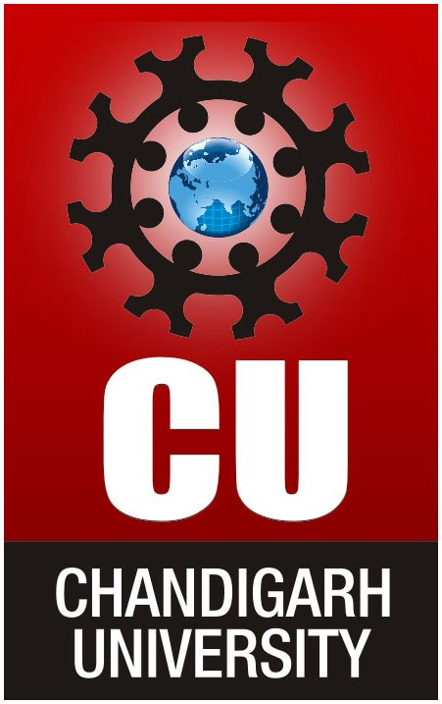

**Submitted To: Submitted By:**

**Isha Sharma Himanshu Dhiman(15BCS2200)**

**Assistant Professor (CSE) Abhishek Gaur(15BCS2170)**

**Chandigarh University Rishav Raj(15BCS2116)**

**SUBJECT – IOT**

**DEPARTMENT OF APPLIED SCIENCE & ENGINEERING**

**CHANDIGARH UNIVERSITY**

**GHARUAN, MOHALI, PUNJAB, INDIA-140413**

**2018**

**ACKNOWLEDGEMENT**

We would like to express our special thanks of gratitude to our teacher Er. Isha Sharma who gave us the golden opportunity to do this wonderful project on the topic Simple TV to smart TV(based on IOT), which also helped us in doing a lot of Research and during which we came to know about so many new things about IOT, we are really thankful to her.  
Secondly we would also like to thank our peers and friends who helped us a lot in finalizing this project within the limited time frame.

**ABSTRACT**

The goal of this report is the presentation of our IOT project “SIMPLE TV TO SMART TV” based on python. Python is an interpreted high-level programming language for general-purpose programming. This Project introduces a system which focuses on cost reduction and provides quality of services in the field of technology and teaching aids. The project uses Raspberry pi and its web interface to store and retrieve files which will be send via remote sources. The proposed system aims to convert a simple monitor screen or any television sets into a smart one by providing a high processing power using Raspberry pi. In return this will lead to drastic cost reduction of smart television sets as well as in teaching technique and helps achieving quality of services. The complete system is wireless which can be controlled remotely.

**LIST OF FIGURES**

|  |  |  |  |
| --- | --- | --- | --- |
| S. No. | Fig No. | Title | Page No. |
| 1. | 1 | Working of a media center | 7 |
| 2. | 2 | Raspberry Pi | 9 |
| 3. | 3 | Wiring diagram | 10 |
| 4. | 4.1 – 4.4 | Screen shots | 11-12 |

**TABLE OF CONTENTS**

1. **INTRODUCTION**
2. **ARCHITECTURE**
3. **SOFTWARE AND HARDWARE REQUIREMENTS.**
4. **WIRING DIAGRAM**
5. **SCREEN SHOTS**
6. **CONCLUSION AND FUTURE SCOPE**

**INTRODUCTION**

A smart TV, sometimes referred to as connected TV, hybrid TV, or intelly (portmanteau of the words intelligent and telly), is a television set with integrated Internet and interactive "Web 2.0" features. Smart TV is a technological convergence between computers and flat screen television sets and set-top boxes. Besides the traditional functions of television sets and set-top boxes provided through traditional broadcasting media, these devices can also provide Internet TV, online interactive media, over-the-top content (OTT), as well as on-demand streaming media, and home networking access.

Smart TV should not be confused with Internet TV, IP TV or with Web TV. Internet TV refers to receiving television content over the Internet instead of traditional systems (terrestrial, cable and satellite) (although Internet itself is received by these methods). Internet Protocol television (IP TV) is one of the Internet television technology standards for use by television broadcasters. Web television is a term used for programs created by a wide variety of companies and individuals for broadcast on Internet TV.

In smart TVs, the operating system is preloaded or is available through the set-top box. The software applications or "apps" can be preloaded into the device, or updated or installed on demand via an app store or app marketplace, in a similar manner to how the apps are integrated in modern smartphones

**ARCHITECTURE**

This Project introduces a system which focuses on cost reduction and provides quality of services in the field of technology and teaching aids. The project uses Raspberry pi and its web interface to store and retrieve files which will be send via remote sources. The proposed system aims to convert a simple monitor screen or any television sets into a smart one by providing a high processing power using Raspberry pi. In return this will lead to drastic cost reduction of smart television sets as well as in teaching technique and helps achieving quality of services. The complete system is wireless which can be controlled remotely.

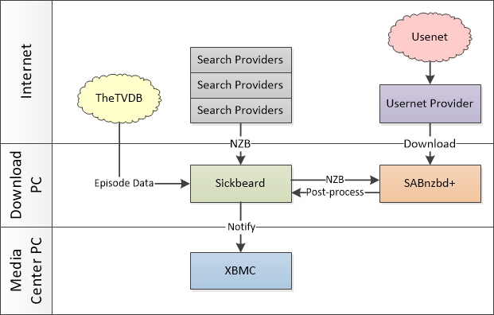

**Fig. 1 : Working of a Media center**

**HARDWARE AND SOFTWARE REQUIREMENTS**

**● Hardware Requirements:**

○ Raspberry Pi 3 Model B: The Raspberry Pi is a series of small

single-board computers developed in the United Kingdom by the

Raspberry Pi Foundation to promote the teaching of basic computer

science in schools and in developing countries. The original model

became far more popular than anticipated, selling outside its target market

for uses such as robotics. It does not include peripherals (such as

keyboards, mice and cases).

○ HDMI to VGA Converter: To connect the VGA monitor with the

Raspberry Pi.

○ VGA Monitor : The Monitor is used as an output device.

○ USB keyboard and mouse: To provide Input.

○ Headset or speakers: To get audio output.

○ Power Supply: To supply power to the monitor and the Pi.

● **Software Requirements:**

○ Kodi: Kodi is a free Linux based operating system that is specifically

made for organizing and presenting media in a simple to navigate format.

It can be used on computers, but it really shines on a TV. It can easily

organize and present music, videos, Internet, and pictures. Kodi has a

variety of free apps that can be downloaded . One of

the best parts about Kodi, though, is that the look can be completely

customized with new skins.

○ Install an Add-on: You can add some required softwares of skins

according to your choice.

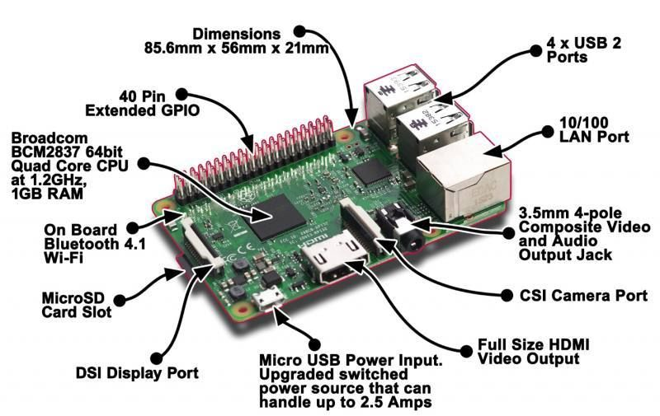

**Fig. 2: Raspberry PI**

**WIRING DIAGRAM**

Project Wiring Diagram Description:

In the project, first of all we need to supply Power to the Pi, and the monitor. Using a

HDMI to VGA converter, we connect the monitor to the Pi.

We also require a USB keyboard and a USB mouse to perform particular input

operations.

For the internet connection we can either use the Built-in WiFi or use an Ethernet Cable for the same.

We also require a Headset/Speaker to be able to listen the audio.

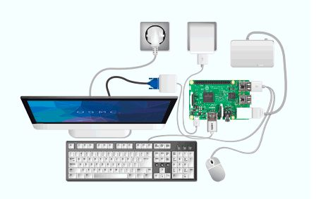

**Fig. 3: Wiring diagram**

**SCREENSHOTS**

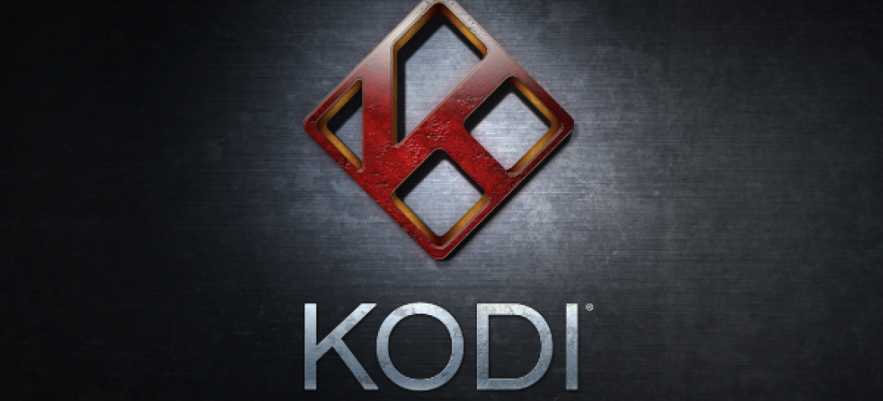

**Fig 4.1**

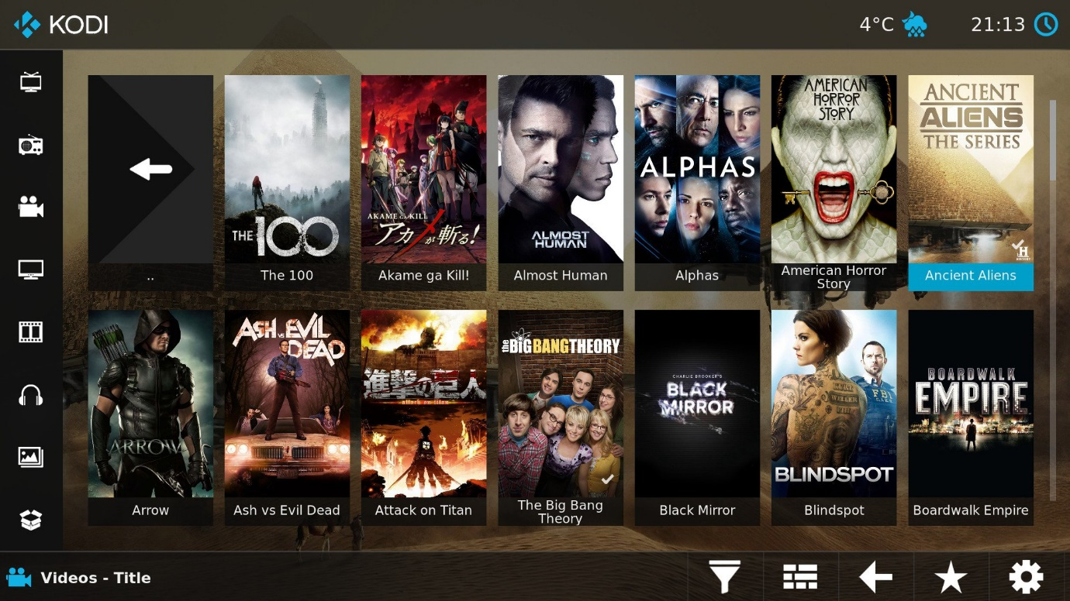

**Fig. 4.2**

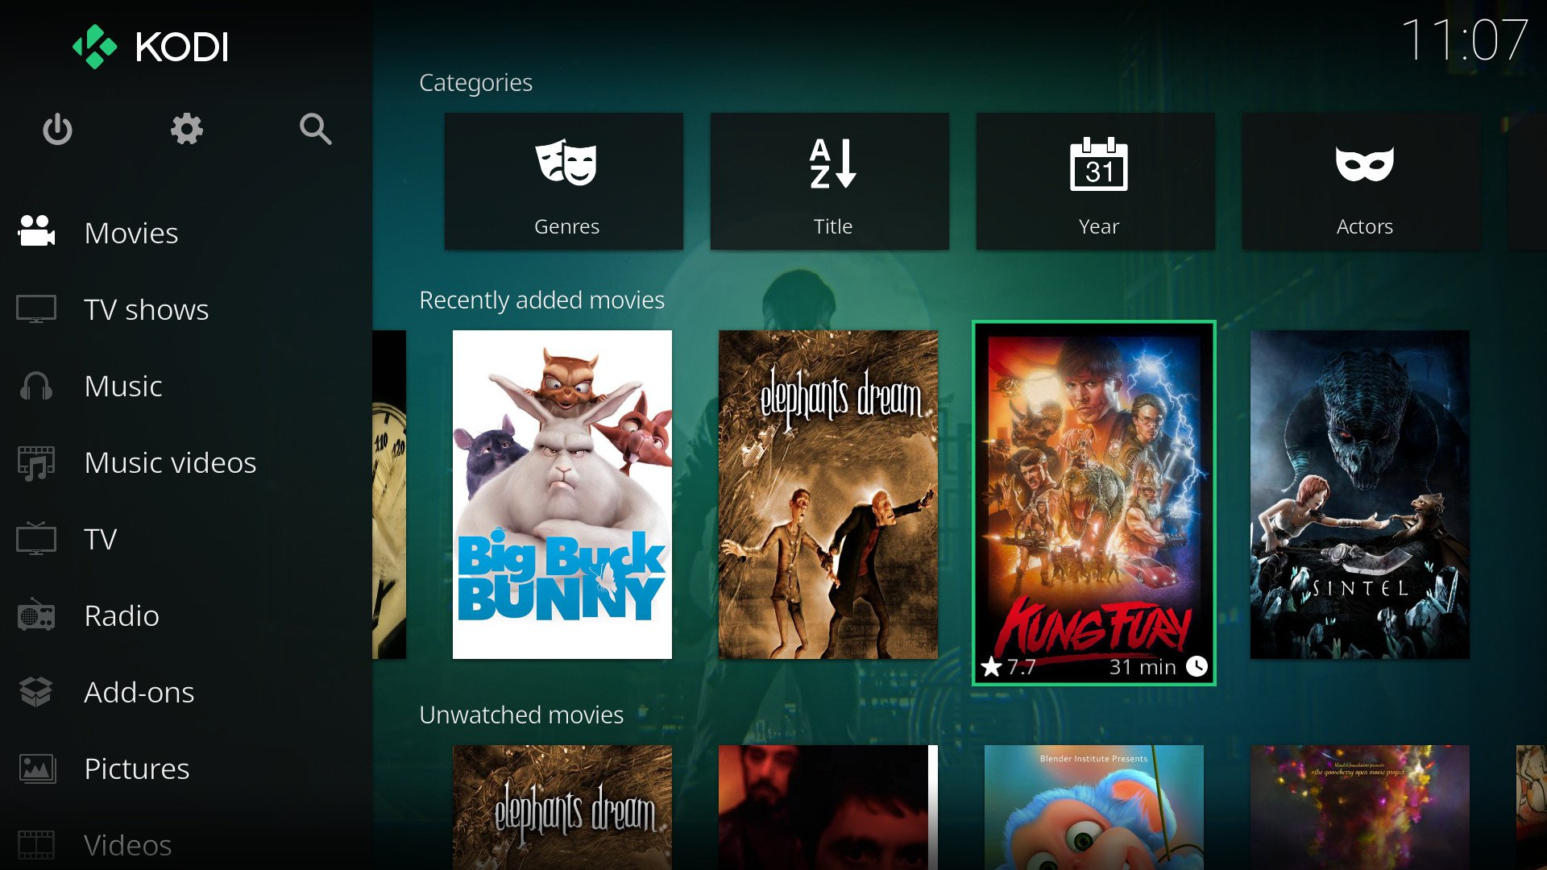

**Fig. 4.3**

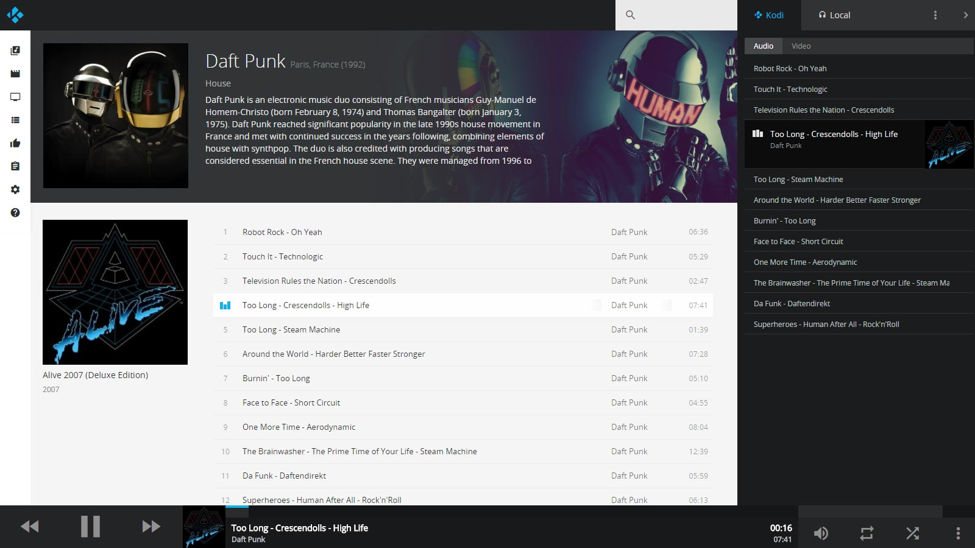

**Fig. 4.4**

**CONCLUSION AND FUTURE SCOPE**

Kodi is a very useful and reliable media center which has many applications. The best part about kodi is that it is an open source software and can be modified according to will. It has many features that makes it capable of competing with its competitors like google chromecast, amazon firestick, mi box.

FUTURE SCOPE

It has a great future due to its nature i.e. it is an open source software.It has many possibilities as it can be modified and uploaded for free.There is a big community of developers that is usually active and solves bugs that come up.

It has a great interface and combining other technologies with it will result in an even better interface and features.

**BIBLIOGRAPHY**

* JOSE-PORTILLA

https://www.youtube.com/watch?v=06GvD3zTRNs14

* INSTRUCTABLES

http://www.instructables.com/id/Make-any-Dumb-TV-a-Smart-TV/

* COURSERA
* YOUTUBE

https://www.youtube.com/watch?vdfvsd6GvD3

* RHYDOLABZ

http://www.rhydolabz.com/wiki/?p=16019

* WIKIPEDIA